Build a Complete Interactive Sales Dashboard from Scratch
What You Will Be Able to Do After This Tutorial
By the end of this tutorial, even if you have never used Tableau before, you will be able to:
- Open Tableau Public (online / free)
- Connect an Excel file to Tableau
- Understand dimensions vs measures
- Create dynamic KPIs (YTD, YoY)
- Build charts (line, pie, donut, bar, table)
- Design a professional dashboard
- Add filters and interactivity
- Publish your dashboard online

What You Need Before You Start
- Tableau Public account (FREE)
https://public.tableau.com
- Car Sales Excel dataset
Tableau Public is enough.
You do NOT need Tableau Desktop.

PART 1 — Understanding Tableau & the Goal (Zero Knowledge Start)
What is Tableau?
Tableau is a data visualisation tool used to:
- Analyse data
- Create charts
- Build dashboards
- Help businesses make decisions
We do not write code in Tableau.
We drag, drop, and calculate.

What is a Dashboard?
A dashboard is:
- A single screen
- With KPIs, charts, and filters
- Used by managers to understand performance at a glance
In this project, we will build a Car Sales Dashboard.

What This Dashboard Will Show
Key Performance Indicators (KPIs)
- Year-to-Date (YTD) Sales
- Year-on-Year (YoY) Growth %
- Cars Sold
- Average Price
Charts
- Weekly sales trend
- Sales by body style
- Sales by colour
- Sales by dealer region
- Company-wise comparison
Filters
- Date range
- Engine type
- Transmission
- Body style
- Gender

PART 2 — Opening Tableau Public & Connecting Data
Step 1: Open Tableau Public (Online)
- Go to https://public.tableau.com
- Click Create → Web Authoring
- Sign in
- Click “Create a Viz”
You are now inside Tableau Public Online.

Step 2: Connect to the Excel File
- Click Upload from Computer
- Select the Car Sales Excel file
- Tableau loads the data automatically
You are now on the Data Source screen.

Step 3: Understand the Data Source Screen
What You See
- Rows = car sales
- Columns = information about each sale
- Data preview (first 100 rows)
Important Columns Explained
- Date → when car was sold
- Car ID → unique sale (very important)
- Price → sales value
- Company, Body Style, Colour, Engine, Transmission → categories
No changes needed here.
Click Sheet 1 at the bottom.

PART 3 — Tableau Basics
Dimensions vs Measures (Very Important)
Dimensions = Categories
Examples:
- Company
- Body Style
- Colour
- Transmission
- Gender
They answer: “What?”

Measures = Numbers
Examples:
- Price
- Annual Income
They answer: “How much?”
Tableau automatically separates them on the left panel.

PART 4 — Creating Dynamic KPIs (Core Learning)
Beginner rule:
Never hard-filter a year. Always calculate it dynamically.

KPI 1 — Year-to-Date (YTD) Total Sales
What is YTD?
Sales for the latest available year in the dataset.

Create Calculation
Right-click → Create Calculated Field
Name: YTD Total Sales
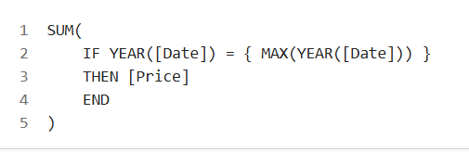
This automatically updates if new years are added.

KPI 2 — Previous Year Sales
Name: Previous YTD Total Sales
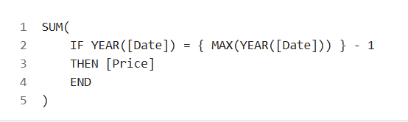
KPI 3 — Year-on-Year (YoY) Growth %
Name: YoY Sales Growth %
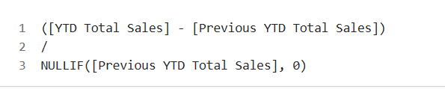
Show KPI
- Drag YTD Total Sales → Text
- Drag YoY Sales Growth % → Text
- Align centre
- Change font size (24+)

Format Numbers (VERY Important)
- Sales → Currency → Millions → $
- Growth → Percentage → 2 decimals

PART 5 — Cars Sold & Average Price KPIs
YTD Cars Sold
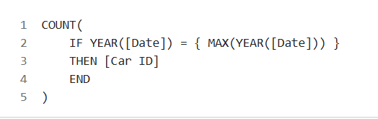
Average Price
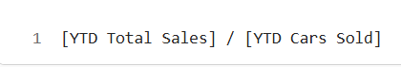
These automatically update with filters.

PART 6 — Weekly Sales Trend (First Chart)
Goal
Show weekly sales trend for the latest year.

Steps
- New Sheet → Name: YTD Weekly Sales Trend
- Drag Date → Columns → Change to Week
- Right-click → Convert to Continuous
- Drag YTD Total Sales → Rows
- Chart type → Line / Area

Highlight Min & Max
- Marks → Label
- Choose Min / Max only

Business Insight
- Overall trend ↑ = growing business
- Dips = investigate promotions, supply issues, holidays

PART 7 — Pie Chart: Sales by Body Style
Steps
- New Sheet → YTD Sales by Body Style
- Change chart → Pie
- Drag Body Style → Colour
- Drag YTD Total Sales → Angle
- Show labels

PART 8 — Donut Chart: Sales by Colour
Donut chart is custom in Tableau.
Steps (Simplified)
- Start with Pie chart
- Create two AVG(0) axes
- Dual axis → overlap
- Inner pie = background colour
- Outer pie = sales
Looks like a donut.

PART 9 — Bar Chart: Dealer Region by Transmission
- New Sheet
- Dealer Region → Rows
- YTD Total Sales → Columns
- Transmission → Colour
- Sort descending

PART 10 — Table: Company-wise Sales Trend
- Company → Rows
- Measure Values → Text
- Add:
  - YTD Sales
  - Cars Sold
  - Average Price
  - % of Total Sales
- Use colour formatting for performance comparison

PART 11 — Creating the Dashboard
Create Dashboard
- Size: 1600 × 900

Add Sheets
- Drag KPIs to top
- Charts in middle
- Table at bottom

Floating Layout (Beginner Tip)
- Switch Tiled → Floating
- Move items freely

PART 12 — Adding Filters (Interactivity)
Filters to Add
- Date (range)
- Engine
- Transmission
- Body Style
- Gender
Apply to All Sheets
- Filter → Apply to Worksheets → All using this data source

PART 13 — Date Range Display
Create two calculations:
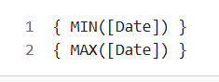
PART 14 — Publish Your Dashboard
- Click File → Save
- Give name
- Tableau publishes it online
- Copy link for portfolio / submission

